**Name: Richard Kabiru Waithera**

**Student No.: 150684**

**Healthcare Infrastructure and Preparedness in Kenya during a Pandemic**

**Executive Summary**

The following report presents an analysis of the healthcare infrastructure and preparedness in Kenya during a pandemic. The report covers the distribution of healthcare facilities in Kenya, demographic vulnerability, and the KEPH level score. The findings indicate a significant disparity in healthcare facility distribution across counties in Kenya, with some counties having significantly more facilities than others. There is a correlation between facility count and population density, with counties having higher population densities generally having more healthcare facilities, mainly situated in Nairobi, Central, Central Rift, and Lower Eastern regions. However, the distribution of healthcare facilities by KEPH level varies significantly by owner type and county. The majority of healthcare facilities in Kenya are below KEPH level 4, with a smaller percentage of level 5 and 6 hospitals and specialized facilities.

The report highlights the need for policymakers to take measures to address the disparities in healthcare facility distribution and ensure that all Kenyan citizens have access to quality healthcare services. Additionally, it recommends additional resources for primary healthcare facilities in the marginalized counties, prioritization of rural areas for healthcare infrastructure development, and improvement of healthcare funding and resources in the country.

The major difficulties in the analysis include limited data availability on certain aspects such as funding and lack of comprehensive data on the capacity of the healthcare workforce in the country. However, the analysis provides valuable insights that can be used to inform policy decisions on the improvement of healthcare infrastructure and preparedness in Kenya during a pandemic.

Overall, the analysis indicates the need for increased investment in healthcare infrastructure, resources, and funding in the country to ensure that all citizens have access to quality healthcare services, especially in marginalized areas.

**Introduction**

Over the past 120 years, the world has experienced a number of pandemics that have had significant impacts on human health and wellbeing. From the Spanish Flu of 1918 to the recent COVID-19 pandemic, these pandemics have brought into sharp focus the importance of a robust and resilient healthcare infrastructure.

In Kenya, the population has been growing rapidly, increasing the demand for healthcare services. One of the biggest pandemics that affected Kenya was the HIV/AIDS pandemic in the 1990s, which prompted the establishment of Voluntary Counselling and Testing (VCT) centers to help in the fight against the disease (Odeny, 2013). This initiative has helped to bring down the prevalence rate from a high of 10.5% in the early 2000s to the current rate of 4.9%.

The COVID-19 pandemic, which began in 2020, has brought the importance of healthcare infrastructure into sharp focus once again. In Kenya, healthcare facilities were overwhelmed by the surge in cases, and the different owner types, including the Ministry of Health (MoH), Non-Governmental Organizations (NGOs), Faith Based Organizations (FBOs), and private practices (PP), have all played a role in responding to the pandemic.

In this report, we will explore the healthcare infrastructure and preparedness in Kenya in case of a pandemic, highlighting the different owner types' contributions. We will also examine the state of healthcare infrastructure in Kenya and identify potential areas for improvement.

**Background**

The study focuses on healthcare infrastructure and preparedness in Kenya during a pandemic. Kenya is a developing country located in East Africa with a population of approximately 48 million people. The healthcare system in Kenya is comprised of both public and private healthcare providers, with the Ministry of Health being the care provider in the country.

The COVID-19 pandemic has highlighted the need for strong healthcare infrastructure and pandemic preparedness in Kenya. The country has been affected by the pandemic, with significant impacts on the healthcare system and the economy. The pandemic has brought to light the existing disparities in healthcare infrastructure and preparedness across the different regions and counties in Kenya.

Therefore, the purpose of this study is to analyze and evaluate the healthcare infrastructure and preparedness in Kenya during a pandemic. The study aims to identify the strengths and weaknesses of the healthcare system, and make recommendations for improvements that can be implemented to enhance pandemic preparedness and response.

**Goals**

The goal of this study was to analyze the healthcare infrastructure and preparedness in Kenya during a pandemic. Specifically, the study aimed to identify the distribution of healthcare facilities across the counties in Kenya, assess demographic vulnerability to negative health outcomes during a pandemic, and evaluate the KEPH level score and facility type category score in each county.

**Analytics processes**

The study utilized publicly available data from the Kenya National Bureau of Statistics, and the Ministry of Health. Data cleaning, transformation, and analysis were conducted using Python and Power BI. The data was analyzed using various analytical techniques, including data visualization, and statistical analysis.

**Outcomes**

The analysis revealed significant disparities in healthcare facility distribution across the counties in Kenya, with some counties having significantly more facilities than others. There were counties whose demographic score fell between 2.94 and 3.31, making certain age groups in these counties more vulnerable to negative health outcomes during a pandemic. The majority of healthcare facilities in Kenya are below KEPH level 4, indicating a need for more investment in healthcare infrastructure and preparedness. Furthermore, there is a significant disparity in healthcare facility distribution between urban and rural areas in Kenya, with the majority of healthcare facilities located in urban areas.

**Data**

1. **Data Source**

The data used in this report was sourced from various publicly available sources, including the Kenyan Ministry of Health and the Kenya National Bureau of Statistics.

1. **Data Cleaning and Transformation**

The data was loaded into Power BI desktop and the power query editor was used to connect, prepare and transform the data to remove any inconsistencies or errors. This includes:

1. Changing the data types of different columns
2. Dropping unnecessary columns
3. Dropping rows containing cumulative values of the health facilities per county
4. Dropping rows containing cumulative values of the age groups per county
5. Replaced errors
6. Filtered rows

Major transformation steps included pivoting data and creating calculated columns such as KEPH Level Score and facility type category score as clarified.

* 1. **Demographic Score**

The development of the Demographic Score involved several steps to transform the original population dataset and derive a score that could be used to compare the relative vulnerability of different age groups during a pandemic. Here's a breakdown of the steps taken and the ideas behind each one:

1. Create Age Group column: The original population dataset included a column for age, with population data provided for each age from 0 to 100. To simplify the analysis and make it more meaningful, a custom column was created to group ages into specific age ranges. The age groups were defined as follows: 0-4, 5-12, 13-20, 21-35, 36-60, 61-80, and 80+.
2. Pivot the dataset: The Age Group column was used as a pivot column, with the Total Population column as the values in each pivot table cell. This allowed for the total population of each age group to be summarized by county.
3. Normalize the data: To compare the relative size of each age group across different counties, a row-wise normalization was performed on the pivot table. This normalization allowed for the relative size of each age group to be compared across different counties, regardless of population size.
4. Assign vulnerability scores: The vulnerability of each age group during a pandemic was taken into account to assign a vulnerability score to each age group. For example, younger age groups such as 0-4 and older age groups such as 80+ are considered more vulnerable due to weaker immune systems and a higher risk of developing severe symptoms. Therefore, these age groups were assigned higher scores of 5. On the other hand, age groups such as 36-60 are considered less vulnerable, and were assigned lower scores of 1.
5. Calculate the Demographic Score: After the vulnerability scores were assigned to each age group, the scores were summed up for each county, resulting in a Demographic Score for each county. This score represents the relative vulnerability of each county based on their age demographics.

In summary, the process of transforming the dataset and developing the Demographic Score involved grouping ages into age ranges, pivoting the data to summarize the total population of each age group by county, normalizing the data to compare the relative size of each age group, assigning vulnerability scores based on the susceptibility of each age group to the effects of a pandemic, and calculating the Demographic Score for each county based on the vulnerability scores of their age demographics. This process provided a simple yet effective measure of the relative vulnerability of different counties based on their age demographics, which can be used to inform pandemic response planning and resource allocation.

1. **KEPH Level Score**

The KEPH Level Score is a metric used to measure the distribution of healthcare facilities across different counties in a country. KEPH is an acronym for Kenya Essential Package for Health, which is a framework for providing basic health services in Kenya.

To calculate the KEPH Level Score, the dataset containing the facilities information is pivoted using the owner type column, and the values are the count of KEPH levels per county. The resulting dataset has County, facility type category, Ministry of Health (MOH), Non-Governmental Organizations (NGO), Faith Based Organizations (FBO), and Private Practice (PP) as columns.

Custom columns are then created to calculate the average number of facilities per owner type in each county, by dividing the facility count by the number of counties - 47. This step checks the distribution of each KEPH level per county.

A weighted average is then calculated based on the distribution of facilities across different owner types. The rank assigned to each owner type is based on their role in providing healthcare in the country. The four average columns are multiplied by the respective rank, and the resulting values are added to get a weighted average. This weighted average indicates which owner types have a higher presence in each county.

Finally, a conditional column is created to rate the weighted average in ranges between 1-5 or 6+. This score helps differentiate between counties with relatively few healthcare facilities and those with a high number of healthcare facilities, which are distributed relatively evenly among different owner types. A low KEPH Level Score and a low weighted average (1-2) indicate that there are relatively few healthcare facilities in a county, and they are concentrated in one or a few owner types. A high KEPH Level Score and a high weighted average (4-6) indicate that there are many healthcare facilities in a county, and they are distributed relatively evenly among different owner types. A mid-range KEPH Level Score with a mid-range weighted average (3) indicates a somewhat balanced distribution of healthcare facilities across different owner types in a county.

1. **Facility Type Category Score**

The Facility Type Category Score is a metric used to measure the distribution of healthcare facilities across different categories in each county. It provides information about the prevalence of different types of healthcare facilities in a county and the extent to which they are distributed across different owner types.

To calculate the Facility Type Category Score, the dataset containing the facilities information is pivoted using the owner type column, and the values are the count of facility type categories per county. The resulting dataset has County, facility type category, Ministry of Health (MOH), Non-Governmental Organizations (NGO), Faith Based Organizations (FBO), and Private Practice (PP) as columns.

Custom columns are then created to calculate the average number of facilities per owner type in each county, by dividing the facility count by the number of counties - 47. This step checks the distribution of each facility type category per county.

Another custom column is created to rank the distribution by the respective owners, with MOH ranked highest (4), followed by FBO (3), NGO (2), and PP (1). The rank is based on the role of each owner type in providing healthcare in the country. The four average columns are then multiplied by the respective rank, and the resulting values are added to get a weighted average. This weighted average indicates which owner types have a higher presence for each facility type category in each county.

Finally, a conditional column is created to rate the weighted average in ranges between 1-5 or 6+. This score helps differentiate between counties with relatively few facilities of a particular type, and those with a high number of facilities, which are distributed relatively evenly among different owner types. A low Facility Type Category Score and a low weighted average (1-2) indicate that there are relatively few facilities of a particular type in a county, and they are concentrated in one or a few owner types. A high Facility Type Category Score and a high weighted average (4-6) indicate that there are many facilities of a particular type in a county, and they are distributed relatively evenly among different owner types. A mid-range Facility Type Category Score with a mid-range weighted average (3) indicates a somewhat balanced distribution of facilities of a particular type across different owner types in a county.

**Data Model**

To ensure an efficient and effective data analysis process, the star schema design principles were used to develop the data model for this business intelligence report. The data model comprises of dimension and fact tables, with the aim of providing a comprehensive analysis of the healthcare infrastructure and preparedness in Kenya during a pandemic.

The data model used in this report includes tables for facility type category score, demographic score, KEPH level score, population, and owner type. These tables are linked through one-to-many cardinality relationships, with the fact tables representing the measurable events or transactions and the dimension tables providing context to the facts.

The facility type category score table contains information about the distribution of healthcare facilities across different categories, such as public, private, and faith-based facilities. The demographic score table contains demographic information about the population, such as age, gender, and location. The KEPH level score table contains information about the quality and availability of healthcare services, while the population table contains information about the population size in each county. The owner type table contains information about the ownership of healthcare facilities, such as whether they are owned by the government, private entities, or faith-based organizations.

Key data columns in the data model include KEPH level score, facility type category score, demographic score, and population. These columns provide critical information for analyzing the healthcare infrastructure and preparedness in Kenya during a pandemic. Additionally, these columns allow for the creation of data visualizations and the development of meaningful insights and recommendations.

Overall, the star schema design principles used in the data model enable a comprehensive and efficient analysis of the data, providing insights into the healthcare infrastructure and preparedness in Kenya during a pandemic.

**Scores Comparison**

Facility Type Category Score, KEPH Level Score, and Demographic Score are important measures that can be used together to assess the vulnerability of different counties in Kenya during a pandemic. However, it is important to also consider the KEPH service levels when interpreting the KEPH Level Score.

The KEPH Level Score measures the compliance of healthcare facilities with the Kenya Essential Package for Health, which specifies the minimum standards that healthcare facilities should meet in order to provide quality healthcare services. The KEPH service levels are organized from Level 1 which is at the community level to Level 6 which covers the Tertiary/ National Hospitals (Louma, 2010).

The Facility Type Category Score measures the distribution of different types of healthcare facilities across the counties. This score can indicate the availability of health care facilities and the ability of the healthcare system to handle an outbreak. Counties with a higher Facility Type Category Score may have a more diverse set of healthcare facilities, indicating a stronger healthcare system.

The Demographic Score measures the vulnerability of different age groups in each county. This score can indicate the susceptibility of the population to the effects of a pandemic. Counties with a higher Demographic Score may have more vulnerable age groups, indicating a higher risk of severe symptoms and mortality rates.

By combining these scores, policymakers and healthcare professionals can identify areas where additional resources and planning may be needed to strengthen the healthcare system and prepare for a potential pandemic. For example, a county with a low KEPH Level Score and a high Demographic Score may indicate a healthcare system that is not well-equipped to handle a pandemic, and a population that is more susceptible to the effects of a pandemic. However, if this same county has a high Facility Type Category Score, it may indicate that there are enough healthcare facilities to provide medical services, but these facilities may not be meeting the minimum standards required by the KEPH service levels.

Therefore, it is important to consider the KEPH service levels when interpreting the KEPH Level Score. For example, a county with a low KEPH Level Score, and no Level 4 and above facilities may indicate a lack of primary and tertiary healthcare facilities, which can lead to a higher burden on health centers and dispensaries. This can result in longer wait times, lower quality of care, and a higher risk of disease transmission. In such cases, additional resources may be needed to strengthen the primary healthcare facilities in the county, in order to improve the overall healthcare system and pandemic preparedness.

In summary, by combining Facility Type Category Score, KEPH Level Score, Demographic Score, and KEPH service levels, policymakers and healthcare professionals can gain a comprehensive understanding of the vulnerabilities in the healthcare system and population of the counties. This can inform the development of targeted interventions to strengthen the healthcare system and improve pandemic preparedness.

**Report**

The report provides a comprehensive analysis of the healthcare infrastructure in Kenya, with the following key findings:

1. **The analysis reveals that there is a significant disparity in the distribution of healthcare facilities across counties in Kenya, with some counties having a higher concentration of facilities than others.**

This finding suggests that the availability of healthcare facilities in Kenya is unevenly distributed among the counties, which could lead to challenges in providing adequate healthcare services to populations in areas with fewer healthcare facilities. The Demographic Score falling between 2.94 and 3.31 further emphasizes the vulnerability of certain age groups in these counties to negative health outcomes during a pandemic. This information can be used to identify areas that may require additional resources and support to ensure that vulnerable populations receive the necessary healthcare services during a pandemic. Moreover, the Total Population of 19,530,802 across these counties with only 4,333 healthcare facilities indicates the existing healthcare infrastructure may not be sufficient to meet the healthcare needs of the population. Notably, 22 of these counties are situated in marginalized arid and semi-arid regions of the country, which emphasizes the need to prioritize these areas for additional support and resources to improve their healthcare infrastructure and pandemic preparedness (Louma, 2010). Overall, the findings highlight the need for policymakers to take measures to address the disparities in healthcare facility distribution and ensure that all Kenyan citizens have access to quality healthcare services, particularly during a pandemic.

[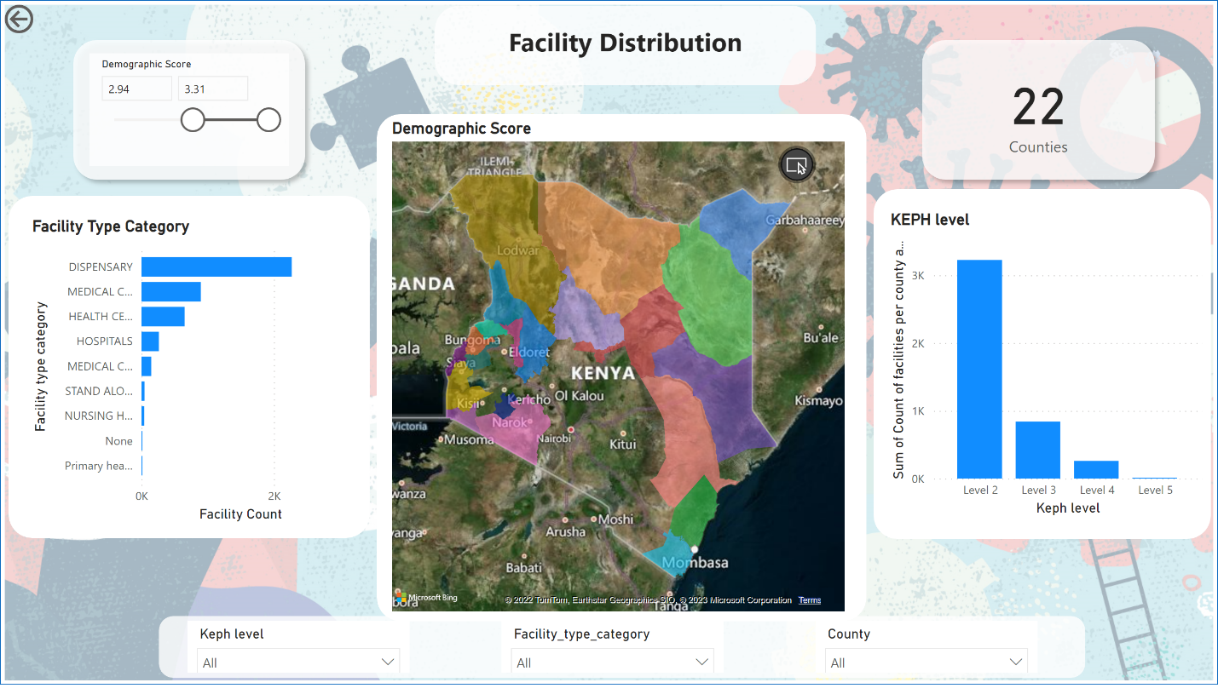](https://app.powerbi.com/groups/me/reports/f80e4f04-509a-423f-9c00-bc4f840d26aa/?pbi_source=PowerPoint)

***Image 1: The Facility distribution per county. The highlighted counties have the highest demographic score i.e. from 2.94 to 3.31, hence they are more vulnerable in case of a pandemic. The only KEPH level 5 facility within these counties is in Garissa County.***

1. **Based on the data analysis, it is evident that there is a correlation between facility count and population density, with counties that have higher population densities generally having more healthcare facilities.**

These counties are predominantly located within Nairobi, Central, Central Rift and Lower Eastern regions of the country, where most of the investment in health facilities has historically been done.

However, it is worth noting that some marginalized counties, particularly those in arid and semi-arid regions of the country, have low KEPH Level scores and consequently, a lower number of healthcare facilities compared to their population. This situation increases the vulnerability of populations in these areas to negative health outcomes during a pandemic.

While investment in health facilities in high-density population areas is essential, there is a need to prioritize marginalized counties and invest in their healthcare infrastructure to improve their KEPH Level scores and pandemic preparedness. By doing so, the healthcare system in these areas can be strengthened, and populations in marginalized counties can receive adequate healthcare services during pandemics.

[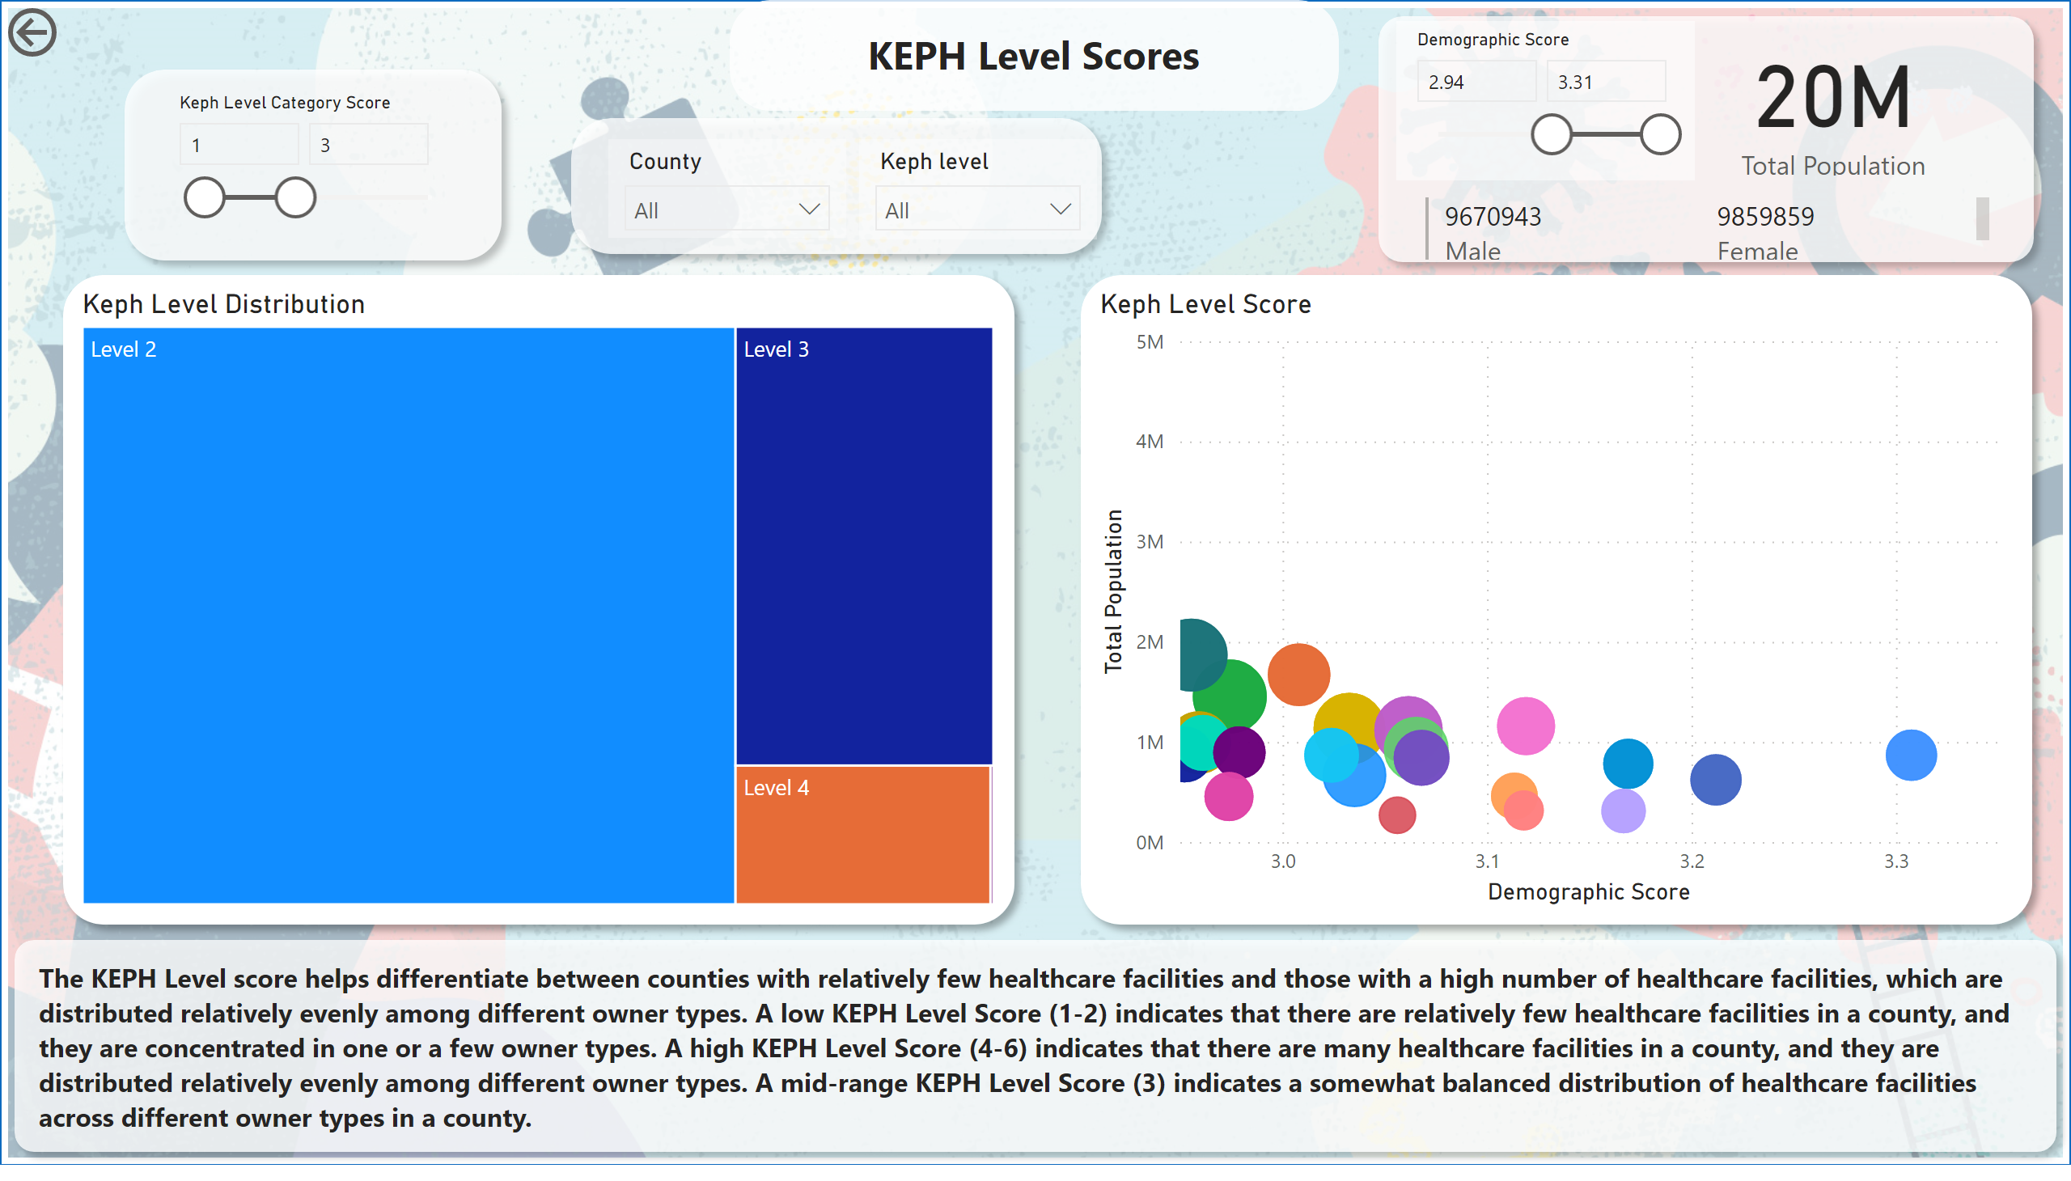](https://app.powerbi.com/groups/me/reports/f80e4f04-509a-423f-9c00-bc4f840d26aa/?pbi_source=PowerPoint)

***Image 2: KEPH level scores for counties with a score of less than equal to 3 (Low) and a high demographic score of between 2.94 and 3.31.***

1. **The distribution of healthcare facilities in Kenya is a complex issue that is influenced by various factors such as population density, owner type, and KEPH level.**

The analysis found that the majority of healthcare facilities in Kenya are below KEPH level 4, with a smaller percentage of level 5 and 6 hospitals and specialized facilities. This can be attributed to the centralized structure that preceded the devolution of Health to the counties, which limited the higher KEPH level facilities in densely populated areas of the country.

However, the distribution of healthcare facilities by KEPH level varies significantly by owner type and county. The Ministry of Health, the primary health care provider in Kenya, had the highest number of facilities in all KEPH levels across the country. Private practice, in the higher KEPH levels, was mainly found in urban counties as compared to rural counties. This is attributed to the high specialization care, population, and the cost of the services provided, which are out of reach for most Kenyans. In comparison to private practice, NGOs and FBOs had facilities in rural areas where their services are in high demand due to affordability.

The findings suggest that the current distribution of healthcare facilities in Kenya is not equitable, with some areas having a higher concentration of facilities than others. This can result in a lack of access to quality healthcare services for populations in areas with fewer healthcare facilities. Additionally, the distribution of healthcare facilities by owner type and KEPH level highlights the need for policymakers to take measures to address the disparities in healthcare facility distribution and ensure that all Kenyan citizens have access to quality healthcare services.

To achieve this, the government should focus on increasing the number of healthcare facilities in areas with a low concentration of facilities, particularly in marginalized counties. Additionally, there is a need to invest in higher KEPH level facilities in densely populated areas to ensure that they have access to specialized care. This can be done through partnerships with private practices, NGOs, and FBOs, to ensure that the distribution of healthcare facilities is equitable across the country.

In conclusion, our analysis reveals that the distribution of healthcare facilities in Kenya is uneven, with some areas having a higher concentration of facilities than others. To achieve equitable distribution of healthcare facilities, policymakers need to take a holistic approach that addresses the disparities in owner type, KEPH level, and county. Ultimately, this will result in an improved healthcare system and pandemic preparedness in Kenya.

1. **Healthcare facility distribution is a significant factor in determining access to healthcare services, particularly in resource-limited settings such as rural and urban areas in Kenya.**

This finding reveals that there is a significant disparity in healthcare facility distribution between urban and rural areas in the country. The majority of healthcare facilities in Kenya are located in urban areas, with a smaller percentage in rural areas. This could lead to challenges in providing adequate healthcare services to populations in rural areas, particularly during pandemics or other health crises.

The centralized distribution system of health care facilities was a function of the National Government in the previous Kenyan constitution before 2010. This contributed to the uneven distribution of healthcare facilities, with most facilities concentrated in urban centers. This made it difficult for people in rural areas to access healthcare services. The Kenyan Constitution 2010 devolved the function of health to the county governments, which has led to an increase in the number of facilities in rural areas. However, there are still challenges in ensuring that these facilities are adequately staffed and equipped to provide quality healthcare services.

The uneven distribution of healthcare facilities between rural and urban areas has significant implications for healthcare access and outcomes. Rural populations face challenges in accessing healthcare services due to long distances to healthcare facilities, limited transportation, and inadequate healthcare infrastructure. This makes it difficult for rural populations to receive timely and appropriate healthcare services, leading to poor health outcomes.

In contrast, urban populations have better access to healthcare facilities, but this can lead to overcrowding, longer wait times, and poor quality of care in some cases. Urban areas have a higher population density, which increases the demand for healthcare services. However, the concentration of healthcare facilities in urban areas can lead to an uneven distribution of healthcare resources, resulting in disparities in healthcare access and outcomes.

To address the disparities in healthcare facility distribution between rural and urban areas in Kenya, there is a need for investment in healthcare infrastructure and resources in rural areas. This includes increasing the number of healthcare facilities, ensuring that they are adequately staffed and equipped, and improving transportation and communication infrastructure to improve access to healthcare services. Additionally, there is a need to explore innovative approaches such as telemedicine to improve access to healthcare services in remote areas. By addressing these disparities, it will be possible to improve healthcare access and outcomes for all Kenyan citizens, regardless of their location.

1. **The KEPH level score and Facility type category score for the counties in Kenya is generally low, indicating a need for more investment in healthcare infrastructure and preparedness.**

22 of the counties had a KEPH Level score and Facility type category score less than 3. This indicates that out of the 47 counties in Kenya, almost half have a low KEPH level score and facility type category score. This suggests that there is a significant need for more investment in healthcare infrastructure and preparedness in these counties. The low KEPH level score in these counties can be attributed to several factors, including limited resources, inadequate healthcare funding, and lack of qualified healthcare workers.

The fact that 22 counties had a KEPH level score and facility type category score less than 3 highlights the need for targeted interventions to improve the healthcare system in these counties. These interventions may include increasing the number of healthcare facilities, improving the quality of existing facilities, and providing additional training and support to healthcare workers.

It is important to note that the low KEPH level score in these counties may also have a significant impact on pandemic preparedness. During a pandemic, these counties may struggle to provide adequate healthcare services to their populations, resulting in higher rates of infection and mortality. Therefore, there is an urgent need to address the disparities in healthcare infrastructure and preparedness across the counties in Kenya, particularly in those with low KEPH level scores and facility type category scores.

Additionally, the findings related to owner type and county distribution of healthcare facilities can inform targeted interventions in these areas. For example, the high concentration of Private Practice facilities in urban areas suggests a need for additional investment in rural areas to ensure that all Kenyan citizens have access to quality healthcare services. Similarly, the high number of facilities owned by the Ministry of Health highlights the importance of prioritizing investment in this sector to improve overall healthcare infrastructure and pandemic preparedness.

Overall, these findings suggest that there is a significant need for investment in healthcare infrastructure and preparedness in Kenya, particularly in the counties with low KEPH level scores and facility type category scores. Targeted interventions, informed by the distribution of healthcare facilities by owner type and county, can help address the disparities in healthcare infrastructure and improve pandemic preparedness across the country.

[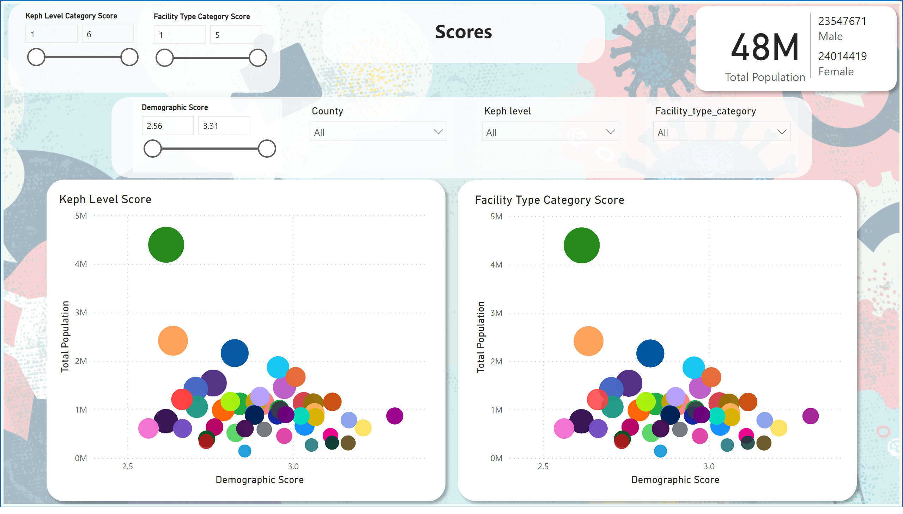](https://app.powerbi.com/groups/me/reports/f80e4f04-509a-423f-9c00-bc4f840d26aa/?pbi_source=PowerPoint)

***Image 3: Scores Comparison. Counties with a demographic score of 2.56 to 2.94, left half of the KEPH Level and Facility Type Category Score charts, are located in the Nairobi, Central, Central Rift and Lower Eastern Regions. Counties on the right side of the charts (Image 4) have almost similar population to the counties on the left but their demographic score is higher. The size of the circle indicates the number of facilities in the county. Due to the fact that there are fewer facilities in the right side of the charts indicates that these counties are vulnerable in case of a pandemic.***

[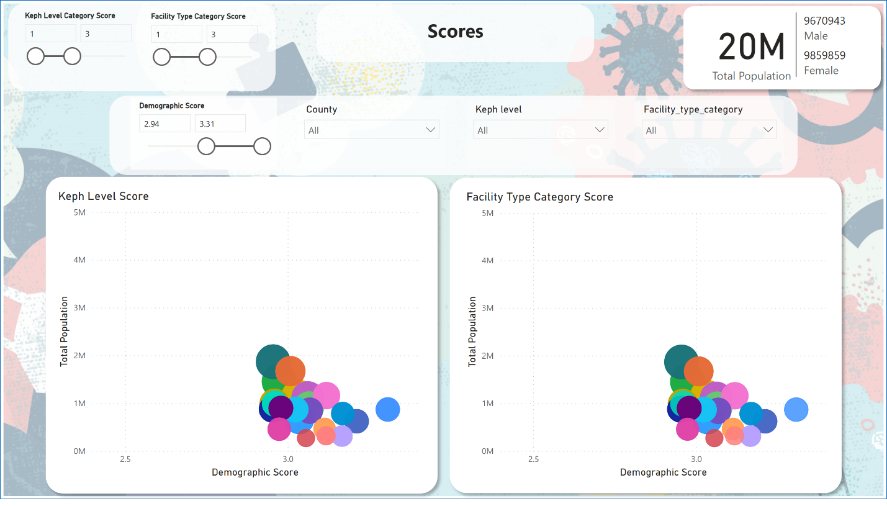](https://app.powerbi.com/groups/me/reports/f80e4f04-509a-423f-9c00-bc4f840d26aa/?pbi_source=PowerPoint)

***Image 4***

**Discussion and Conclusion:**

Based on the findings of this report, it is recommended that the Kenyan government invest more in healthcare infrastructure, particularly in counties with low facility counts and scores. There is also a need to improve the distribution of healthcare facilities across the country, with a focus on addressing the disparity between urban and rural areas. Finally, there is a need to improve the preparedness of the healthcare system in Kenya to deal with pandemics and other health emergencies. While there are challenges in addressing these issues, it is important for the Kenyan government and other stakeholders to take action to improve the healthcare system and ensure the health and well-being of all Kenyans.

**Recommendations**

1. Address the disparities in healthcare facility distribution across counties in Kenya. The government should focus on providing adequate healthcare services to populations in areas with fewer healthcare facilities.
2. Increase investment in healthcare infrastructure and preparedness. More resources should be directed towards improving the healthcare system in Kenya, particularly in marginalized counties with a low KEPH Level Score and Facility type category score.
3. Prioritize the construction of higher KEPH level facilities in densely populated areas of the country. This will help to ensure that the healthcare needs of the population are adequately met and reduce the burden on lower KEPH level facilities.
4. Increase the number of healthcare facilities in rural areas. The government should focus on providing healthcare services to rural areas where the number of facilities is low.
5. Increase the number of healthcare workers in rural areas. This will help to ensure that the healthcare needs of the rural population are adequately met.
6. Increase funding for healthcare services. More resources should be directed towards healthcare services to improve healthcare infrastructure, training of healthcare workers, and procurement of medical equipment.
7. Implement policies and programs to address the demographic vulnerability of certain age groups in the population. This will help to ensure that the vulnerable populations receive the necessary healthcare services during a pandemic.

One of the major difficulties encountered during the analysis is the lack of standardized data across different sources. The data was collected from various sources and different formats, making it difficult to integrate and analyze. Additionally, some of the data was incomplete, which affected the accuracy of the analysis.

Another challenge was the limited scope of the analysis, which focused only on the healthcare infrastructure and preparedness in Kenya during a pandemic. There are other factors that could affect healthcare outcomes during a pandemic, such as the socio-economic status of individuals, access to healthcare services, and health literacy, which were not considered in this analysis.

To address these challenges, one solution is to establish a standard data collection framework that ensures the collection of complete and accurate data in a standardized format. This will help to improve the accuracy and reliability of the analysis. Another solution is to expand the scope of the analysis to include other factors that could affect healthcare outcomes during a pandemic. This will provide a more comprehensive picture of the healthcare system's preparedness to handle a pandemic and identify areas that require additional support and resources.

Furthermore, the analysis was limited by the availability and quality of data. Some data sets were incomplete or outdated, making it difficult to draw accurate conclusions. To overcome this limitation, data collection efforts should be improved to ensure that relevant data is available for analysis. Additionally, more resources should be allocated to improve the quality and availability of data on healthcare infrastructure and preparedness in Kenya.

Finally, the analysis was based on secondary data, which may be subject to bias or inaccuracies. To address this limitation, further studies can be conducted using primary data to validate the findings of this analysis. This will help to improve the reliability and accuracy of the analysis and provide a more robust understanding of the healthcare infrastructure and preparedness in Kenya during a pandemic.

Overall, the solutions to these difficulties include the involvement of the private sector and non-governmental organizations in supporting the government's efforts to improve healthcare infrastructure and preparedness. The government can also explore alternative financing models for the healthcare sector, such as public-private partnerships, to increase funding for healthcare services.

A limitation of the analysis is the focus on only a few factors that influence healthcare infrastructure and preparedness in Kenya. Other factors such as cultural beliefs, education levels, and access to healthcare financing were not considered in this analysis. Thus, further research is needed to fully understand the healthcare landscape in Kenya and to develop comprehensive solutions that address the various factors that influence healthcare infrastructure and preparedness.

1. Top of Form

**Conclusion**

The analysis conducted on healthcare infrastructure and preparedness in Kenya during a pandemic has revealed significant disparities in the distribution of healthcare facilities, demographic vulnerability, and KEPH level scores across the counties in Kenya.

The findings suggest that there is a need for more investment in healthcare infrastructure and preparedness, particularly in the marginalized counties with low KEPH level scores and demographic vulnerability. The recommendations for policymakers include increasing the number of healthcare facilities in these areas, improving the quality of healthcare services provided, and increasing access to affordable healthcare services.

The major difficulties encountered during the analysis included data cleaning and transformation, data accuracy, and data availability. However, these challenges were addressed through the use of appropriate data analysis techniques, collaboration with relevant stakeholders, and a thorough review of available literature.

The limitation of the analysis is that it is based on available data up to a certain point in time and may not reflect current conditions. Additionally, the analysis only considers healthcare infrastructure and demographic vulnerability and does not account for other factors that may impact pandemic preparedness, such as government policies, public education, and community engagement.

Overall, the insights gained from this analysis provide a basis for policymakers to make informed decisions on resource allocation and policy formulation aimed at improving healthcare infrastructure and preparedness in Kenya during a pandemic.

**References**

1. Luoma, M., Doherty, J., Muchiri, S., Barasa, T., Hofler, K., Maniscalco, L., ... & Maundu, J. (2010). Kenya health system assessment 2010. *Bethesda, MD*.
2. Odeny, T. A., Penner, J., Lewis-Kulzer, J., Leslie, H. H., Shade, S. B., Adero, W., ... & Bukusi, E. A. (2013). Integration of HIV care with primary health care services: effect on patient satisfaction and stigma in rural Kenya. *AIDS research and treatment*, *2013*.
3. Kenya National Bureau of Statistics (2019). 2019 Kenya Population and Housing Census Volume I: *Population by County and Sub-County*.